Check this out.

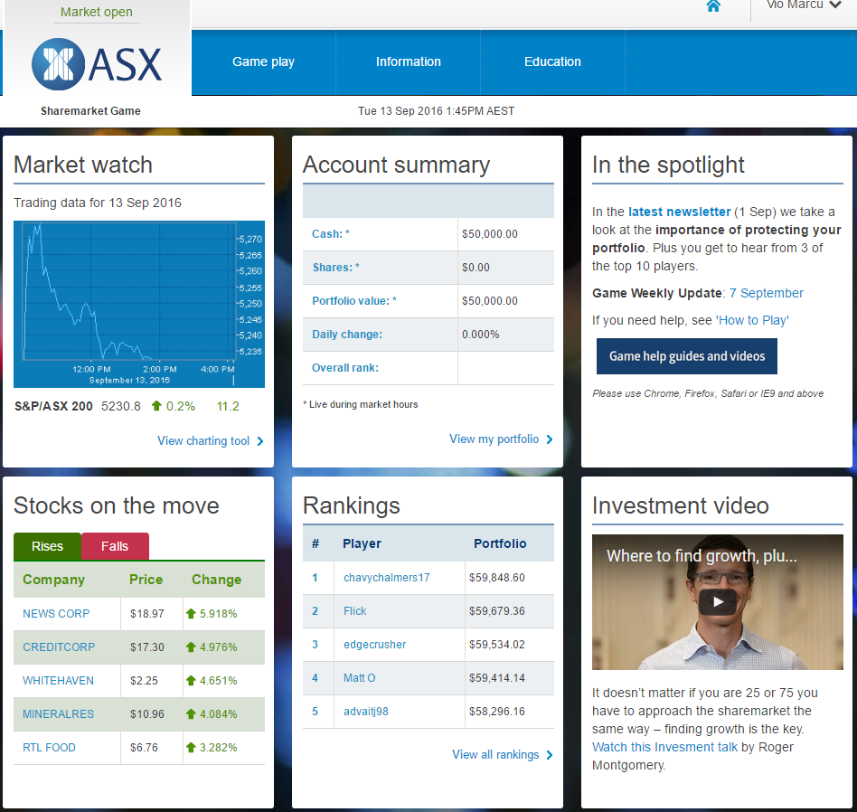

About this game: <https://game.asx.com.au/game/info/public/about-the-game>

I’ve signed up and logged in as a player and there are many features here similar to what we are required to do.

